Yacht updates, agents, charter and berths opportunities.
Unable to view this newsletter? Open a webpage

Newsletter | 42nd issue l February 16th 2022

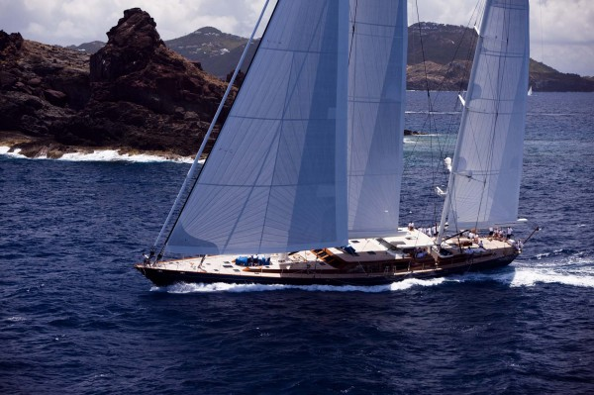
News from Head Office
Despite all the turmoil in the world, I hope you can enjoy your free time on the water this year.
We can certainly help you make your dreams come true. When it comes to buying or selling your yacht or making a trip on a charter, we organize it.
Recently we have renewed completely our website. I hope it is a fine website with many new offers and extensions in the field of yachts, charters and moorings.
Many things happen in the world of yachting and we want to be there. You too?
Marcel Borgmann
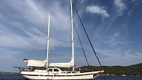S/Y STEEL KETCH 19M “RAUSCHKUGEL“
Rauschkugel is a dutch steel construction from 1984.
READ MORE >

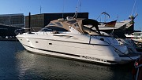M/Y SUNSEEKER CAMARGUE 50 ``Pylos``
Pylos is a beautiful Sunseeker Camargue 50 with 2 double cabins with en-suites and a convertible dinette in the saloon.
READ MORE >

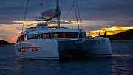S/C Dufour 48 Catamaran “Dreamland”
“Dreamland” is now for sale. This is an almost factory new Dufour 48 catamaran, located in Croatia.
READ MORE >

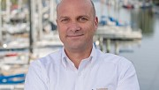agent Sea Independent Germany and Mallorca
We focus on quality.
READ MORE >

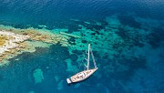Charter Trintella 65
Morning Calm III: A celebration of many years of boat ownership, Morning Calm was conceived and built for family cruising in comfort and style.
READ MORE >

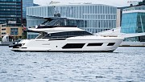M/Y Ferretti 670
Ferretti 670 was launched for the company’s 50th anniversary in 2018
READ MORE >

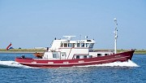M/Y EX VISKOTTER UK 161 ``Sylvia``
Originally built as a fishing vessel named UK 79
READ MORE >

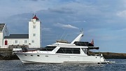M/Y Ocean Alexander 46 Sedan Trawler ``Tide``
Here is the opportunity to become the owner of this well-maintained and rare Ocean Alexander 46 Sedan Trawler. Flemming, DeFever and others.
READ MORE >

agent Sea Independent Norway
Rune Riktor (52) is a Norwegian yacht broker, and has successfully cooperated with Sea Independent to find buyers and sellers across borders.
READ MORE >

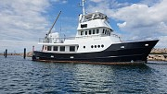M/Y EXPLORER YACHT 22M “BONITO“
built in 1976 by Johs Kristensen in Hvide Sande as a research cutter for the Federal Republic of Germany, from 2000-2004.
READ MORE >

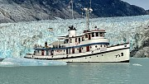Charter Classic Exploration Yacht
The exploration ship Sacajawea was originally built by the Army Corp of Engineers in 1936.
READ MORE >

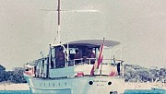M/Y James A. Silver 58
This unique James A. Silver 58 Motor Yacht has been with the same owner for the last 30 years and is now ready to be enjoyed by her new owner.
READ MORE >

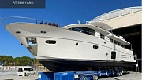M/Y Apreamare Maestro 82
The luxurious Maestro 82 is the flagship of the line and of the entire fleet and it was launched in 2008.
READ MORE >

agent Sea Independent Spain,
She started working for the renown company Flensburger Yacht Service on Mallorca running the Nautor’s Swan Germany-Austria Office in Port Adriano in 2013.
READ MORE >

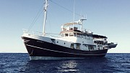Gentleman Explorer ``Zeewoelf``
The fishing cutter Zeewoelf was built in 1960. After a long adventurous career in the north sea which included guarding oil rigs,
READ MORE >

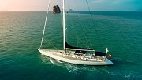S/Y NAUTOR SWAN 86
The 86-foot sailing superyacht ASPIRATION is a proven world-cruising, ocean-sailing yacht.
READ MORE >

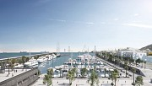Berths in all beautiful places of the world.
Beside berths in Montenegro, Mallorca, Ibiza, Barcelona, Italy and Caribbean we can offer;
READ MORE >

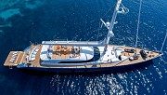50m Custom Build Sailing Yacht
Albatros is a 50m custom built super sailing yacht with a displacement of 664 Ton.
READ MORE >

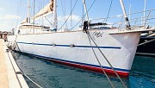MOTORSAILER ``WK London``
This spacious luxury custom built motorsailer is ready to set sail around the world
READ MORE >

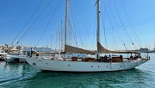S/Y Alden Schooner ``Phoenix``
S/Y Phoenix was built in 1999/2001 as a Modern Classic to the plans drawn by John Alden in 1931.
READ MORE >

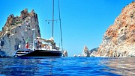S/Y Nauta 57
Nauta Yachts are known to be long-legged blue water cruisers designed to sail offshore. With a length of over 17 meters, you get a good experience even if it is a little sea.
READ MORE >

© 2021 Sea Independent b.v. all rights reserved | www.seaindependent.com
e: mail us  t: +31 229279753  m: +31 653922797  s: sea.independent  Please click here to unsubscribe | Sea Independent BV  Grote Oost 24  1621 BW Hoorn  The Netherlands |  | FOLLOW US:
 |  |  |  facebook
 |  |  |  twitter

